Click SQL WORKSHOP and after the drop down menu comes click SQL Scripts.

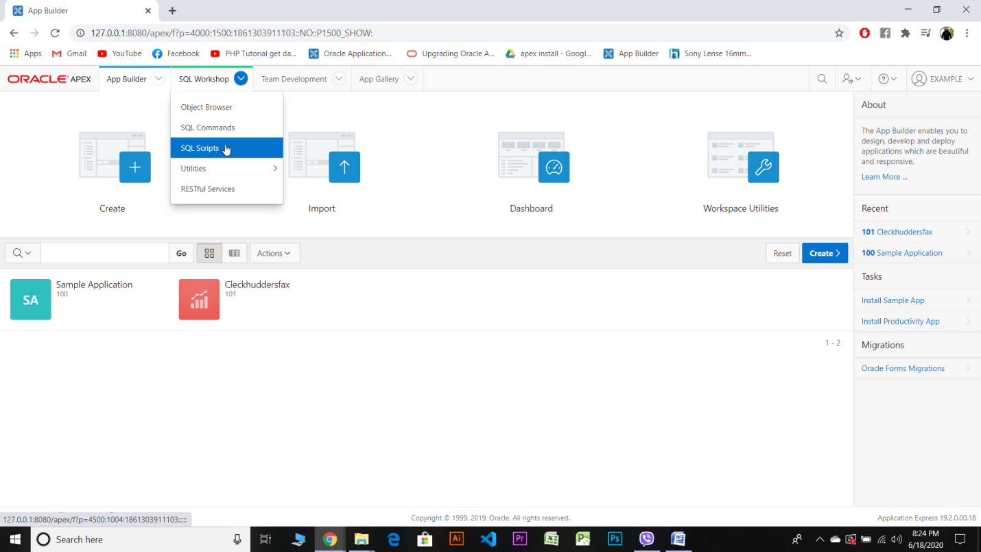

Click on upload.

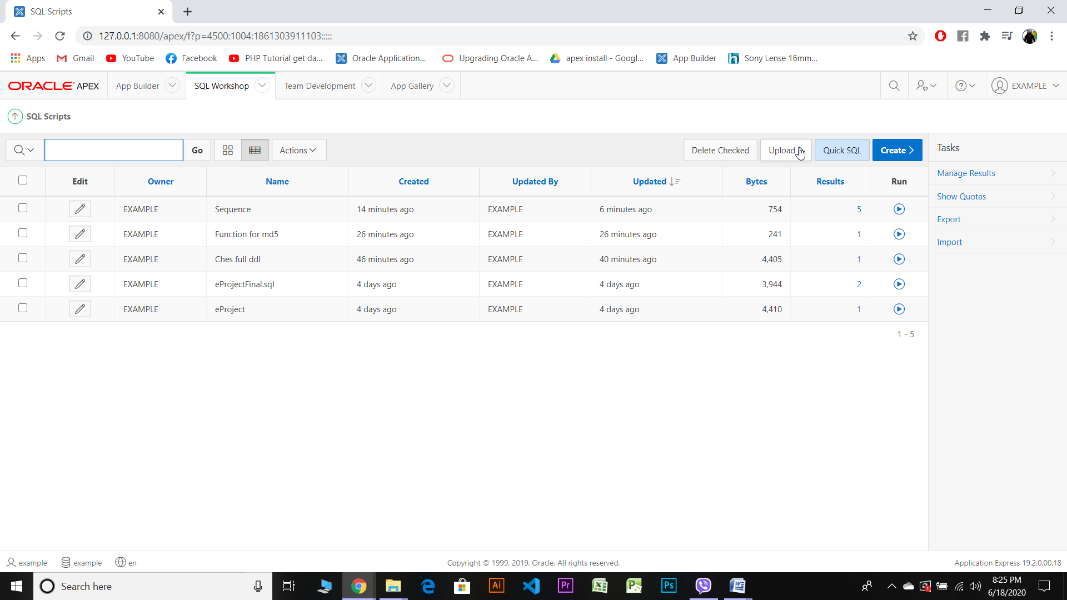

Choose your corresponding file by click on choose file and go to the respective directory and folder .

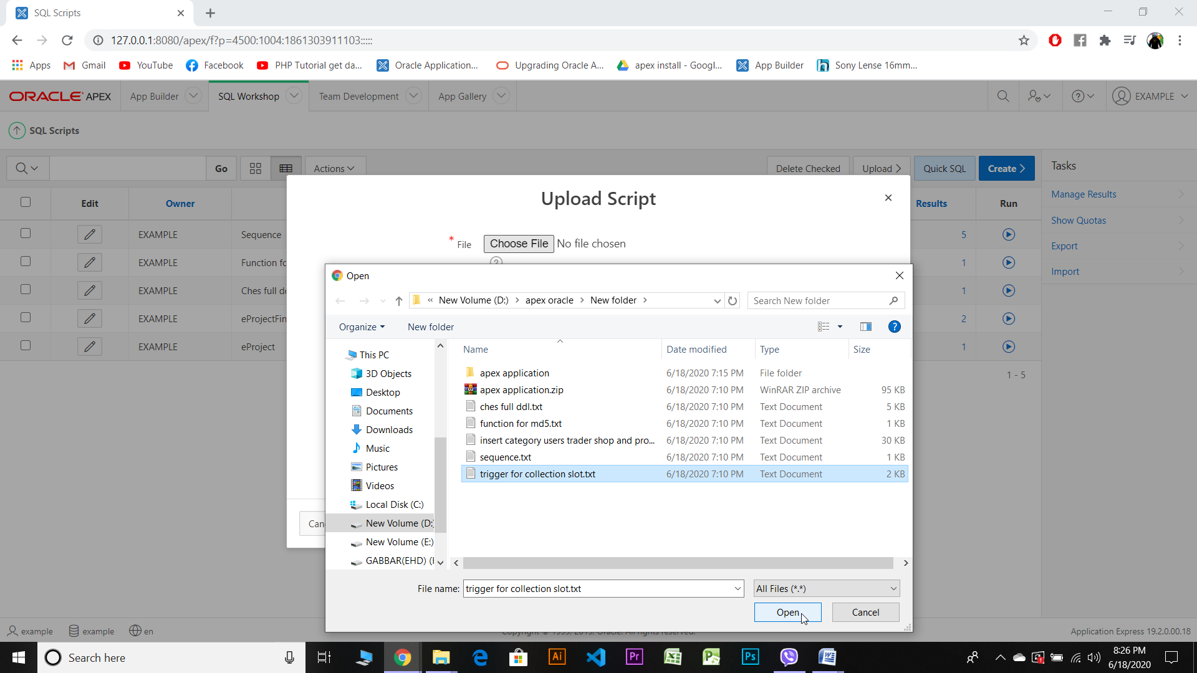

Click upload to upload the selected file by giving a name.

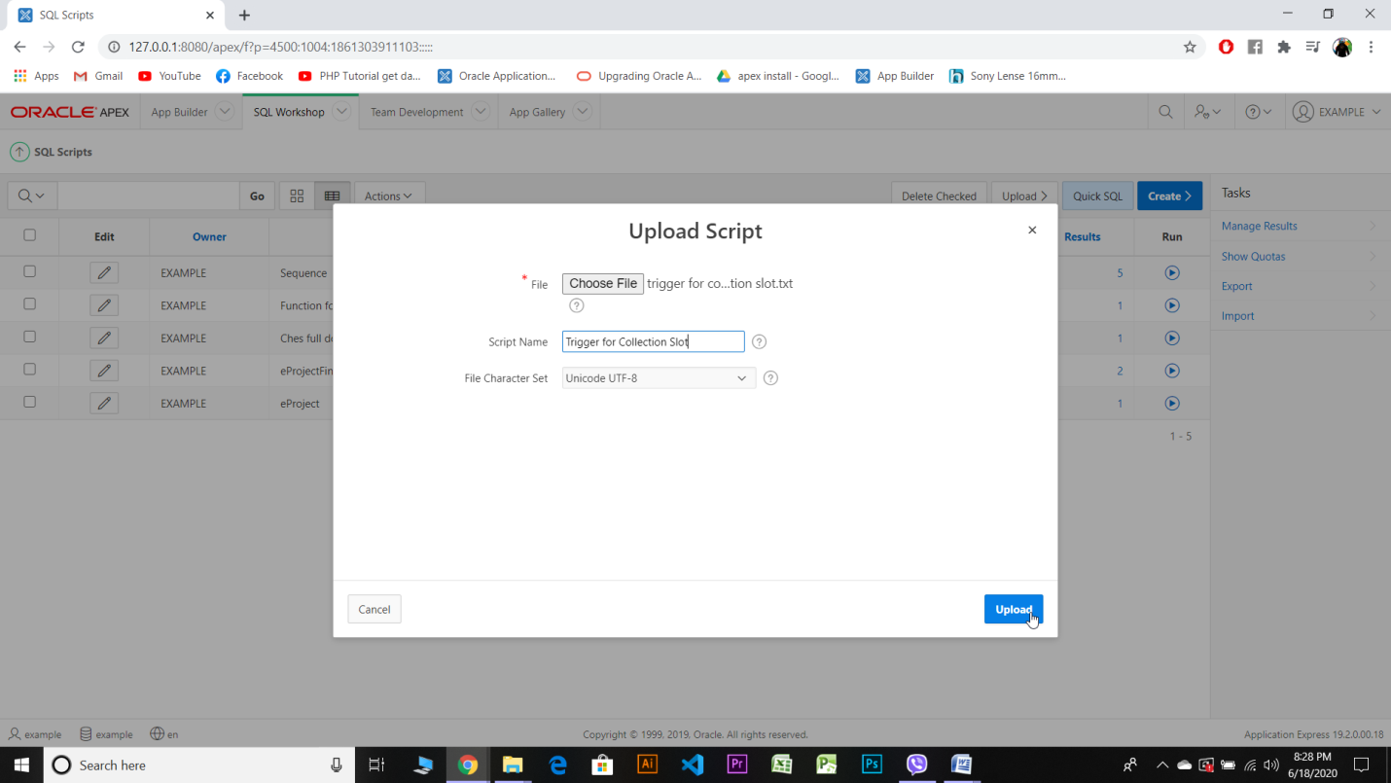

When the upload is done your file name is shown like this and then click run.

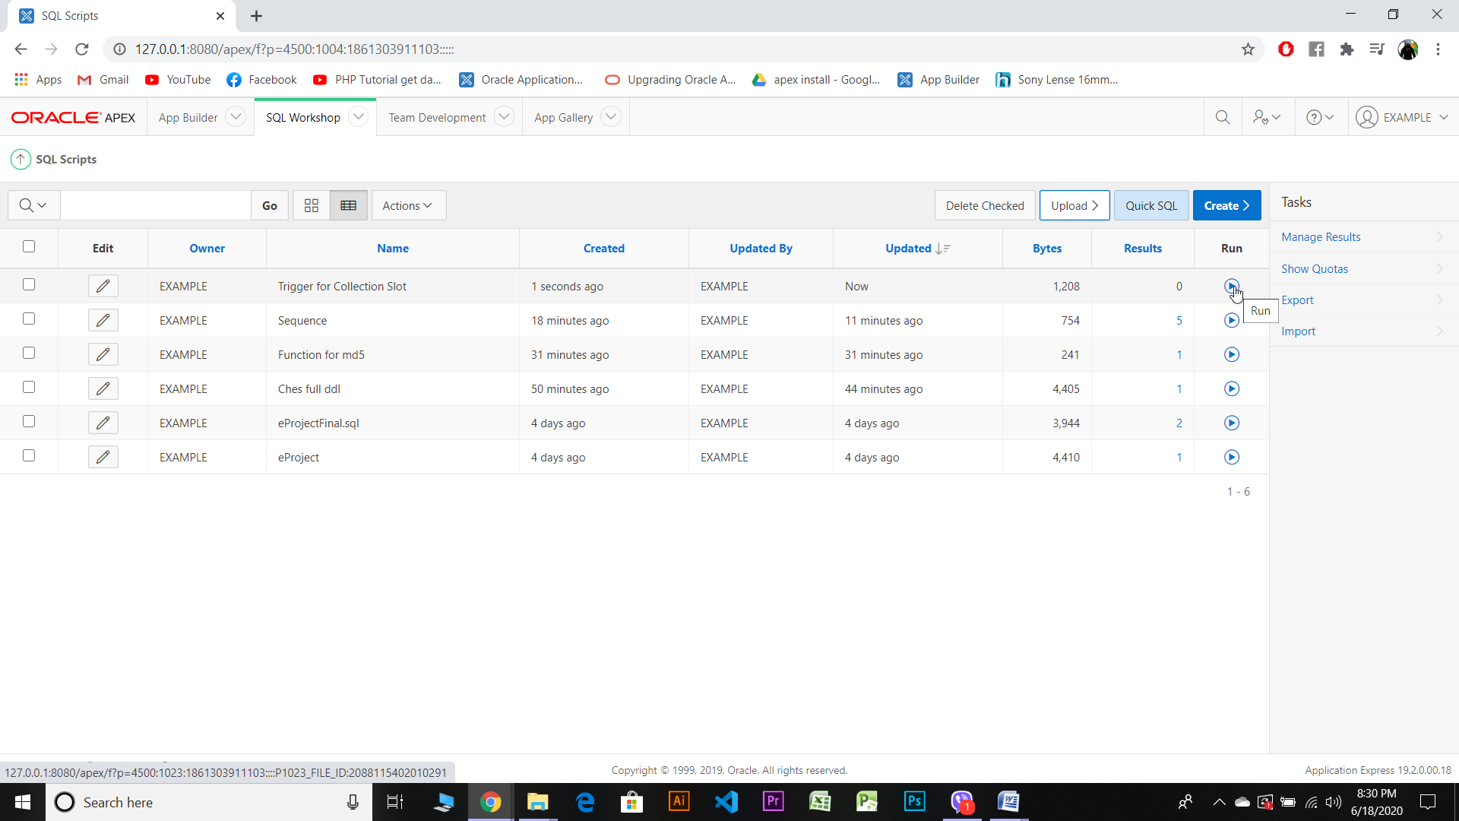

After clicking run, this will apper on your screen.Then,Click Run Now.

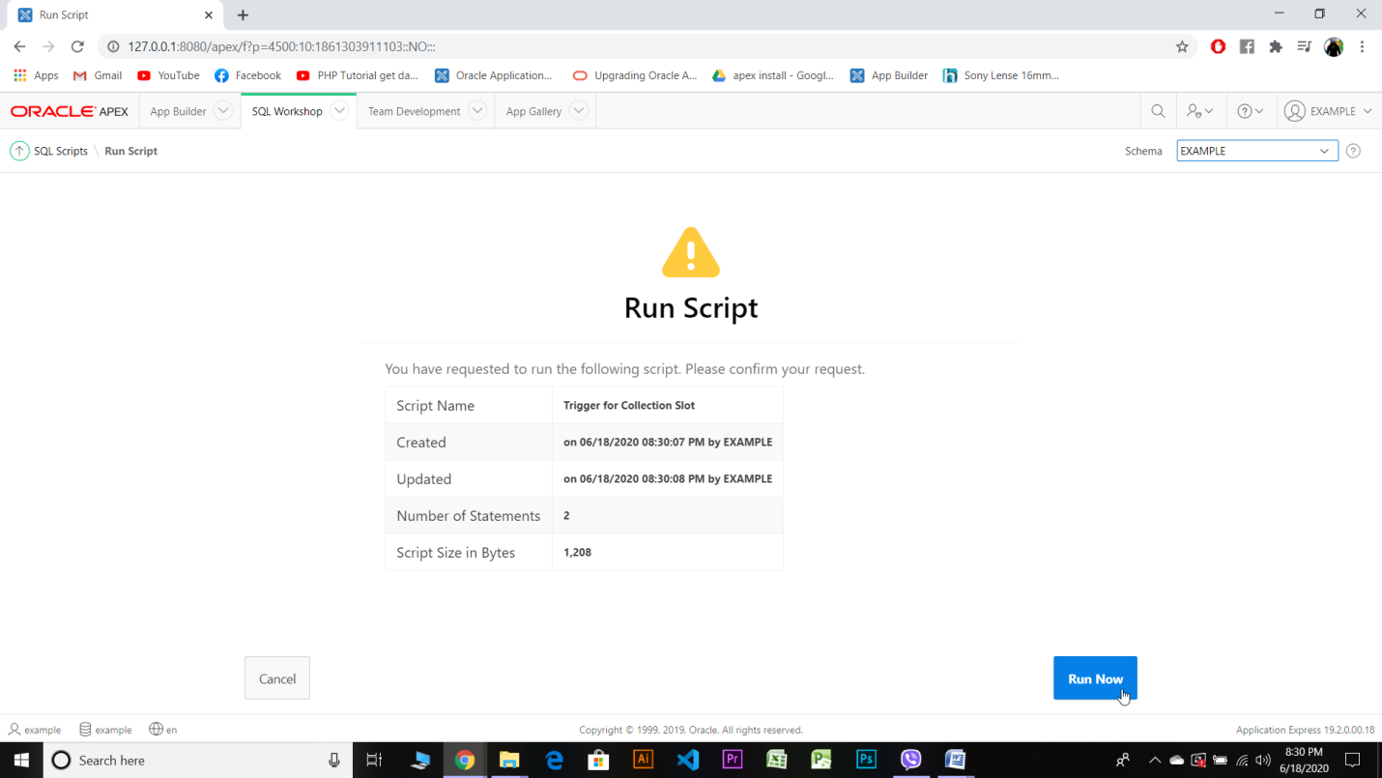

Then trigger will be created and altered with 0 error.

